Accessibility Guide for Herdwick Cottage Ambleside
info@HerdwickCottageAmbleside.co.uk, 07973 382176, www.HerdwickCottageAmbleside.co.uk
Contact for accessibility enquiries: Sarah Strachan

https://www.accessibilityguides.org/content/herdwick-cottage-ambleside
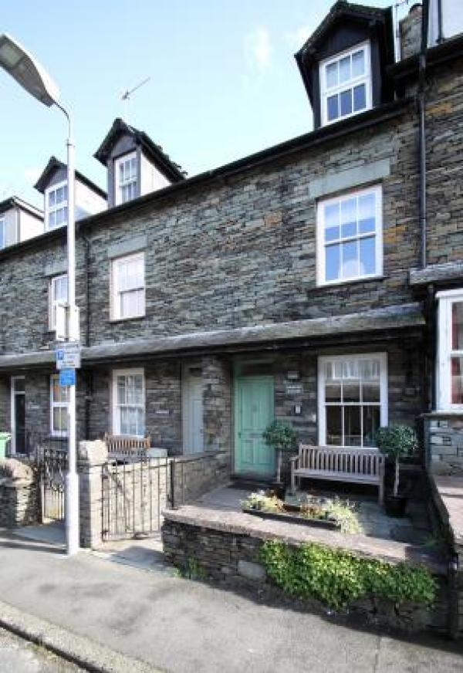

Welcome
Herdwick Cottage is a traditional 4* Victorian Lakeland stone cottage in a quiet road in the heart of Ambleside within the stunning English Lake District National Park, a UNESCO World Heritage site.
Beautifully refurbished, Herdwick Cottage is a 3 bedroom, 2 bathroom self-catering cottage for up to 5 people and is spread over three floors. Explore stunning scenery and return to a cosy log burner fire, gorgeous kitchen and basement games room.
Please note we are a pet-free and smoke-free cottage.

At a Glance

Level Access
- The main entrance has 1 step. There is no lift and no ramp.
- There is level access from the main entrance to:
  - Lounge
  - Dining room

Access with steps
- There are steps from the main entrance to:
  - Bedroom
  - Outdoor rear patio

Bedrooms
- We have non-allergic bedding.

Hearing
- The (bedroom) TVs have subtitles.

Getting here
Herdwick Cottage, 8 Millans Park
Ambleside
LA22 9AG

Travel by public transport
- You can get to Herdwick Cottage Ambleside by bus and train.
- The nearest bus stop is the interchange on Kelsick Road. The bus stop is 0.3 miles / 0.5 km from Herdwick Cottage Ambleside.
- The nearest train station is Windermere. The train station is 5 miles / 8.1 km from Herdwick Cottage Ambleside.

Travel by taxi
- You can get a taxi with Lakeside Taxis by calling 015394 888 88. The taxi company has a wheelchair accessible vehicle.

Parking
- There is parking near the venue. Parking is free.
- There is on street visitor's parking for which a parking permit is provided (on the coffee table). You may need to park round the corner until a space is available outside the property. From the parking to the main entrance, there is 1 step. There is no ramp and no lift. The property is a traditional terraced building accessed up a kerb and one small step to the front door. It is not wheelchair accessible inside unfortunately due to the narrow build and layout. Inside there are three staircases, one to the basement (there is a low ceiling as you go down these stairs), and one to the first floor and then the second floor. All have handrails.

Arrival

Path to main entrance
- From the street to the main entrance, there is 1 step. There is no ramp and no lift.

Main entrance
- The main entrance has 1 steps.
- The main door is side hung and manual.

Getting around inside

Bedrooms
- All bedrooms have windows.
- Bedrooms have ceiling lights, bedside lamps and natural daylight.
- Lights are LED and traditional filament. TVs have subtitles.
- All bedrooms are non-smoking.
- We have non-allergic bedding.
- All bedrooms have fitted carpets.
- All bedding is non-allergenic.
- No bedrooms have level access. The bedroom nearest the main entrance has 15 steps.
- We have bathrooms with a separate shower.
- We have bathrooms with a bath.

Self catering kitchen

Kitchen
- We have a separate kitchen and dining room. From the main entrance to the kitchen, there is level access.
- From the main entrance to the dining room, there is level access.

Lounge

Lounge
- From the main entrance to the lounge, there is level access.

Dining room
- From the main entrance to this area, there is level access.

Getting around outside

Outdoor rear patio
- From the main entrance to the area, there is 1 step.

Customer care support

Guide last updated: 15 August 2022

